Course Title: Basic Nutrition

Grade Level: 6th - 8th grade

Description:
In this course, you will learn about the fundamentals of nutrition and will develop skills to make informed, healthy food choices that will support your physical growth and overall well-being.

*Double Check Standards*
Missouri:
ME2A6-8
ME2B6-8
ME2C6-7
ME2E7
ME3A6 & 8

Arkansas:
HW.12.6.2
HW.12.6.3
HW.12.6.4
HW.12.7.3
HW.12.7.4
HW.12.8.3
HW.12.8.4
HW.12.8.5

Course Image:
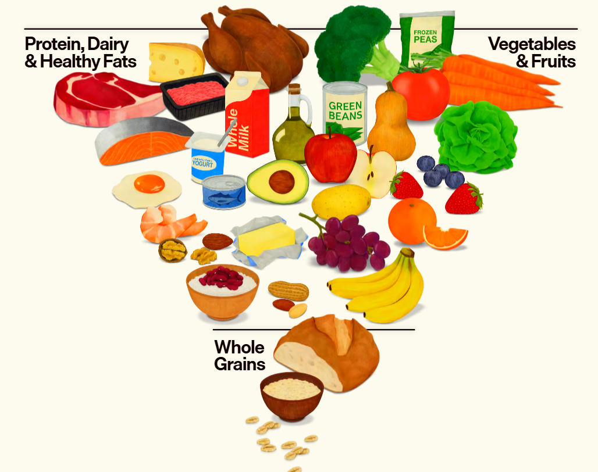
Video URL:
Healthy Eating for Teens: The Ultimate Guide to Fuel Your Body 🍎💪

